Getting Beyond the Label: What makes high-quality HIPs?
Jillian Kinzie, IU Center for Postsecondary Research & Laurette Foster, Prairie View A&M University

Evergreen Summer Institute 2019

High-Impact Practices (HIPs) = Educational experiences that make a significant difference to student persistence, learning outcomes, and student success. Beneficial to all students, particularly historically underrepresented students. Yet, not all students get to partake in HIPs. About 23% of students across all 4-year C&Us, and about 11% in 2-year sector, participate in LCs. According to NSSE, first-generation, adults, and international students a little less likely to participate in LCs; students of different racial-ethnic groups had an equal likelihood of participation in LCs; Biol. science, education, engineering majors are more likely be in LCs, and physical sciences, and undecideds less likely.
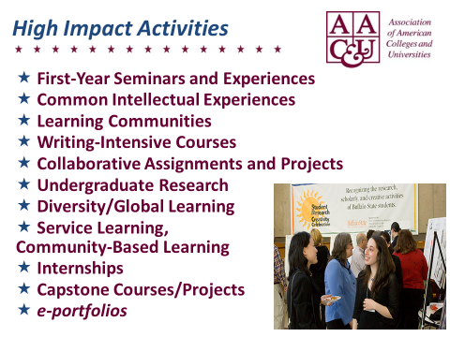 | 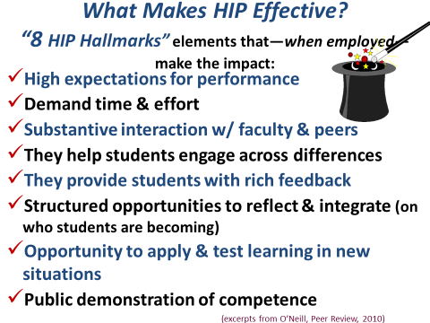

High-Impact Practices: Eight Key Elements and Examples for Learning Communities
(adapted from: Ensuring Quality & Taking High-Impact Practices to Scale by George D. Kuh and Ken O’Donnell, with Case Studies by Sally Reed. Washington, DC: AAC&U, 2013). For information and research from LEAP, see www.aacu.org/leap.

Performance expectations set at appropriately high levels. Example: A writing-or inquiry-intensive learning community course in which assignments, projects, and activities require students to integrate learning across courses and experiences -- challenging students to achieve beyond their current ability levels.
Signiﬁcant investment of time and effort by students over an extended period of time. Example: A multiple-part assignment or project on which a student works over the course of the term—beginning with a synopsis of the problem or issue to be examined and the methods or procedures that will be used; followed subsequently with narrative sections describing the ﬁndings and conclusions which culminate in a completed paper; concluding with demonstration or performance.
Interactions with faculty and peers about substantive matters. Example: Out-of-class activities in which learning community students come together 5-6 times over the term to attend an enrichment event—such as a lecture by a visiting speaker and/or a discussion of common readings and assignments facilitated by an upper-division peer mentor.
Experiences with diversity, wherein students are exposed to and must contend with people and circumstances that differ from those with which students are familiar. Example: A service-learning ﬁeld assignment wherein students work in a setting populated by people from different backgrounds and demographics, such as an assisted living facility or shelter for abused children, which is coupled with residence hall or class discussions and journaling about the connections between readings and the ﬁeld assignment experience.
Frequent, timely, and constructive feedback. Example: A group learning community project during which students meet with and receive suggestions from faculty (or staff) member at various points to discuss progress, next steps, and problems encountered and to review the quality of students’ contributions up to and through the completion of the project.
Periodic, structured opportunities to reﬂect and integrate learning. Example: Linked courses in a learning community wherein an instructor of one course designs assignments that require students to draw on material covered in the other linked courses, supplemented by a peer mentor who coordinates student involvement and discussion at relevant campus events.
Opportunities to discover relevance of learning through real-world applications Example: A themed learning community (poverty, environmental issues, urban art, social movements) that requires students apply knowledge and skills acquired in the LC to reﬂect on and see the connections between their studies and experiences in particular real world settings.
Public demonstration of competence. Example: An oral presentation to classmates that is evaluated by a faculty member and/or an accomplished practitioner, or staff member.

HIP Matrix: Designing High Quality Learning Communities with HIP Hallmarks in Mind
How much are these hallmarks emphasized in your LCs? X = limited/no emphasis, + = strong emphasis; ?= not sure
 | High-Impact Practices Hallmarks
AAC&U  Hallmarks | High expectations for performance | Demand time & effort | Substantive interaction w/faculty & peers | They help students engage across differences | They provide students with rich feedback | Structured opps. to reflect & integrate (who students are becoming) | Opportunity to apply & test learning in new situations | Public demonstration of competence
Learning Community

- What HIP hallmark(s) do your LCs do well? Describe your practice.

- What HIP hallmark(s) would you like to emphasize in your LC? What might you do?

- Is there another HIP (service-learning, undergraduate research, writing intensive, etc.) that you could build into (introduce, offer an experience) in your LC to expose students to a second HIP?

