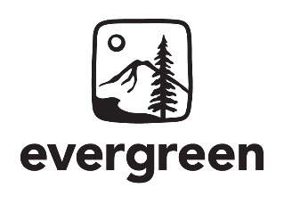
Olympia, Washington

Program Coordinator

For complete details and to learn how to apply for this position visit: https://evergreen.edu/employment/

Position Purpose
This position reports to the Dean of Native Programs and Experiential Learning to support the collaboration between a diverse set of programs, staff, and faculty in supporting and coordinating initiatives, programming, and educational events. This position spends about 65% of the time working with Native Programs, including the Tribal Liaison, Native Cases project, and curriculum which includes part-time courses, undergraduate programs, and one graduate program. The position spends about 35% of the time performing a broad range of administrative duties, including support for the Dean Native Programs and Experiential Learning and assisting on projects that promote and support the mission of Experiential Learning at Evergreen, including the public service centers, individual study (e.g. internships), and study abroad.

This is a half-time (20 hour per week), overtime eligible, project position in Native Programs and Experiential Learning on the Olympia campus of The Evergreen State College. This project position is grant funded through June 30, 2028 with continuation dependent on additional funding.

Salary and Benefits: $1,756.50 – $2,340.50 per month of half-time work + excellent benefits including paid sick and vacation leave; paid campus holidays; a generous medical, dental, life, and disability insurance package; and a tuition waiver program.

Closes: June 25, 2025
All requested application materials must be submitted by the deadline in order to be considered.

About the College
The Evergreen State College is a progressive, public liberal arts and sciences college located in Olympia, Washington, in the beautiful Pacific Northwest. Since opening its doors in 1971, Evergreen has established a national reputation for leadership in developing innovative interdisciplinary, collaborative and team-taught academic programs. The college has a vibrant undergraduate program, graduate programs, and public service centers that constitute a unique academic setting. The college values a student-centered learning environment, a link between theory and practice, and a multicultural community of diverse faculty, students and staff working together. For more information about Evergreen, please visit our college catalog or our website: http://www.evergreen.edu

Application Process
For details on the application requirements and process visit: https://evergreen.edu/employment/

All qualified applicants will receive consideration for employment without regard to race, color, religion, sex, sexual orientation, gender identity, national origin, age, genetic information, disability, or status as a protected veteran. For more information regarding Evergreen’s non-discrimination policies or to report discrimination, please visit the Affirmative Action and Equal Opportunity webpage at https://www.evergreen.edu/equalopportunity or contact the Affirmative Action and Equal Opportunity Officer at (360) 867-5371, Room 3102 Library Building, 2700 Evergreen Parkway NW, Olympia, WA 98505.

