- This quiz is for you to display your personal understanding of program material
- You may use a single 3 inch by 5 inch note card and a calculator
- Show/explain all work/reasoning. You will be evaluated on clarity/completeness of process, not simply on answer
- The quiz begins at 9:00 and ends promptly at 9:15

- Rolling downhill, a cyclist hits a top speed of 42 miles per hour. How many meters per second is this?

- A hand of an analog clock (shown below) moves from the 12:00 straight-up position to the 2:00 position. Through what angle (in radians) does it pass? (You may express your answer either in decimal form or as a fraction.)

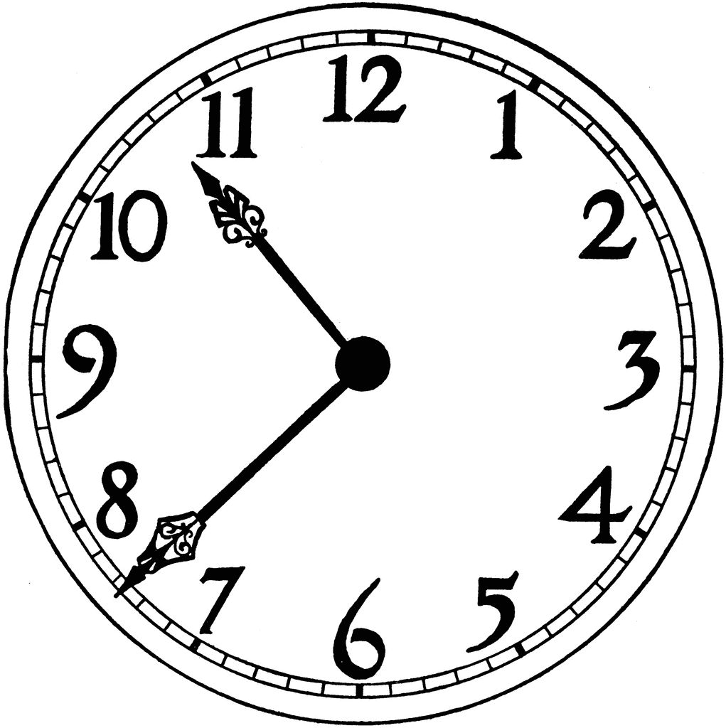

- One cubic foot is how many milliliters (1 milliliter = 1 cm³)?

- The picture shows a warning, “Smoking is Not Allowed Within 50’ – 0” of This Building.” How many meters from the building should a smoker be before smoking?

