Qu Yuan’s Legacy seminar
Lily M.
5/29/25

- Who witnessed and narrated creation’s very beginning?
According to the Law of Conservation of Energy, no energy can be created or destroyed. Therefore, the energy that exists in everyone and everything today has existed before in different forms, even at the very beginning of creation. So, though you don’t remember it, the energy in you and everyone else witnessed the creation of everything.
- How can we fathom the formless void before existence?
It may not be possible to remember or fathom the formless void before existence. However, maybe it is possible to visit that place again, perhaps it is the same formless void after existence.
- Who grasped the chaos before day and night parted?
The Earth, the Stars, all the Cosmos. Though they cannot share the story. They were there to witness the chaos before day and night parted.
- How can we recognize the world in the churning mists of pre-creation?
In the same way you could recognize your home with your eyes closed or know your friends from just their voices. You can recognize the world even in the churning mists of pre-creation because it is so familiar you’d recognize it no matter what.
- What compelled light and shadow to first divide?
Shadow and light are not divided; they are complementary. These forces are acting together for the benefit of all living things.
- How did these primal energies fuse and transform?
These primal energies fused and transformed by acting as a balance to one another. To maintain harmony, these forces constantly worked together until they were nearly inseparable.
- Who plotted the concentric wheels of the cosmos?
The concentric wheels of the cosmos were formed as a balance between life-giving forces and forces of destruction. This balance creates harmony in the cosmos and has led to the optimal conditions for the formation of life on our planet.

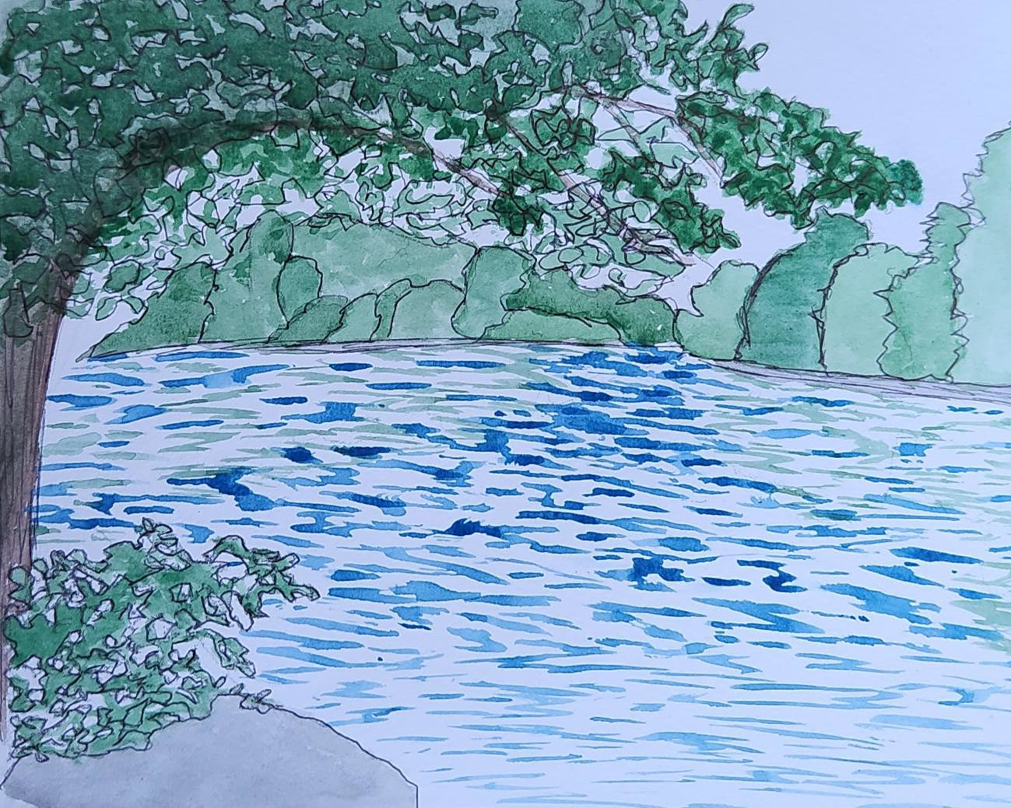
While reflecting on the meaning of Qu Yuan’s questions and attempting to create my own authentic answers for them, I was reminded of our earlier discussion of rivers and their significance to cultures around the world. For our river assignment, I painted the Duwamish River and as these two assignments feel so connected to me, I would like to share it here as well.

Fatima:
Title: Still Asking Heaven
Qu Yuan’s Question:
“Why were the stars scattered across the sky—who set them in motion?”
My Response:
Maybe they’re breadcrumbs
left by ancestors
guiding us through midnight struggles.

Maybe God knew we’d be out here
trying to find light when we feel lost.
So they gave us stars
and stories
to remind us:
we’ve always had a path
even when the map feels torn.

Original Question to Heaven:
Why do Black girls have to carry whole bloodlines on our backs
and still be told we’re "too much"
when we shine?

Reflection:
When I read about Qu Yuan being exiled and misunderstood, I thought: damn, that hits home. Black folks, especially women—know what it means to be cast out for being too passionate, too bold, too honest. Like Qu Yuan, we turn pain into poetry, displacement into rhythm, and legacy into light.
His "Questions to Heaven" made me think of all the times I’ve looked up angry,
confused, tired and wanted to scream, "Why?" The world still feels like a Warring State. We’re fighting systems, stereotypes, and generational curses. And still, like him, we write.
We question. We create.
This assignment reminded me that my voice is part of something ancient. Maybe not dragon boats, but the way we celebrate Juneteenth, or dance under summer suns that’s ancestral too. Our festivals might not look the same, but they carry the same heart: remembrance, resistance, rebirth.

Thomas Brown
Global Perspectives
05/25/25

Questions to the Universe “Dialogues with Heaven”

1. I stared at these two questions for over three hours, attempting to capture my feelings with words. These specific questions flooded my brain with thoughts, questions, and images of creation. My mind was running wild with ideas of how to write my responses. After reading dozens of poems and philosophical quotes online and writing a similar amount of my own, I was finally able to express my thoughts.

"In the primal dawn of time, who passed down the tales?"
The essence of the cosmos entwined,
woven into the fabric of the universe,
creating the tapestry of our very existence.

"Brightness and darkness alternating—what force drove them?"
To understand the forces that separated light and dark, one must first recognize the interconnection that once bound them.

2. I have too many questions I would like to ask the universe. These are the three I settled on for now.
Why is there suffering of innocent people in the world?
Is there a relationship between faith and science?

How can humans align with the path of the universe?I created this art in our journal (markers, colored pencils, and icons pens) as an interpretation of my poem response to Qu Yuan’s question,
"In the primal dawn of time, who passed down the tales?"
The essence of the cosmos entwined,
Woven into the fabric of the universe,
Creating the tapestry of our very existence.

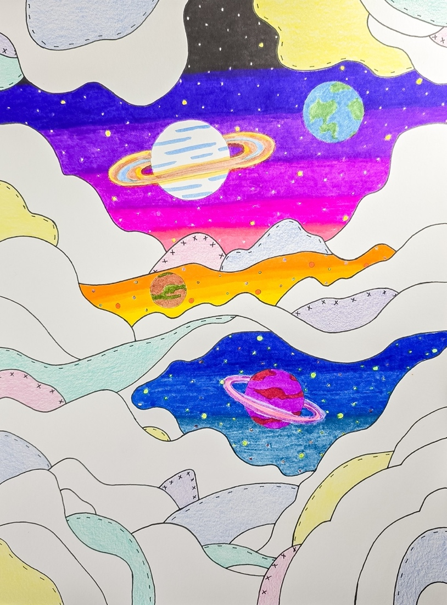

MarIah Jett
1.
O Sky, where satellites blink like cold stars,
Do you mourn the silence of forests
as we upload our prayers to the cloud?
2.
Heaven, where do the lost signals go—
the messages we text in heartbreak,
never read, never answered?
3.
You who once birthed suns from nothing,
Can you still see the soul
beneath algorithms and glowing glass?

