Qu Yuan’s Legacy seminar
Lily M.

- Who witnessed and narrated creation’s very beginning?
According to the Law of Conservation of Energy, no energy can be created or destroyed. Therefore, the energy that exists in everyone and everything today has existed before in different forms, even at the very beginning of creation. So, though you don’t remember it, the energy in you and everyone else witnessed the creation of everything.
- How can we fathom the formless void before existence?
It may not be possible to remember or fathom the formless void before existence. However, maybe it is possible to visit that place again, perhaps it is the same formless void after existence.
- Who grasped the chaos before day and night parted?
The Earth, the Stars, all the Cosmos. Though they cannot share the story. They were there to witness the chaos before day and night parted.
- How can we recognize the world in the churning mists of pre-creation?
In the same way you could recognize your home with your eyes closed or know your friends from just their voices. You can recognize the world even in the churning mists of pre-creation because it is so familiar you’d recognize it no matter what.
- What compelled light and shadow to first divide?
Shadow and light are not divided; they are complementary. These forces are acting together for the benefit of all living things.
- How did these primal energies fuse and transform?
These primal energies fused and transformed by acting as a balance to one another. To maintain harmony, these forces constantly worked together until they were nearly inseparable.
- Who plotted the concentric wheels of the cosmos?
The concentric wheels of the cosmos were formed as a balance between life-giving forces and forces of destruction. This balance creates harmony in the cosmos and has led to the optimal conditions for the formation of life on our planet.

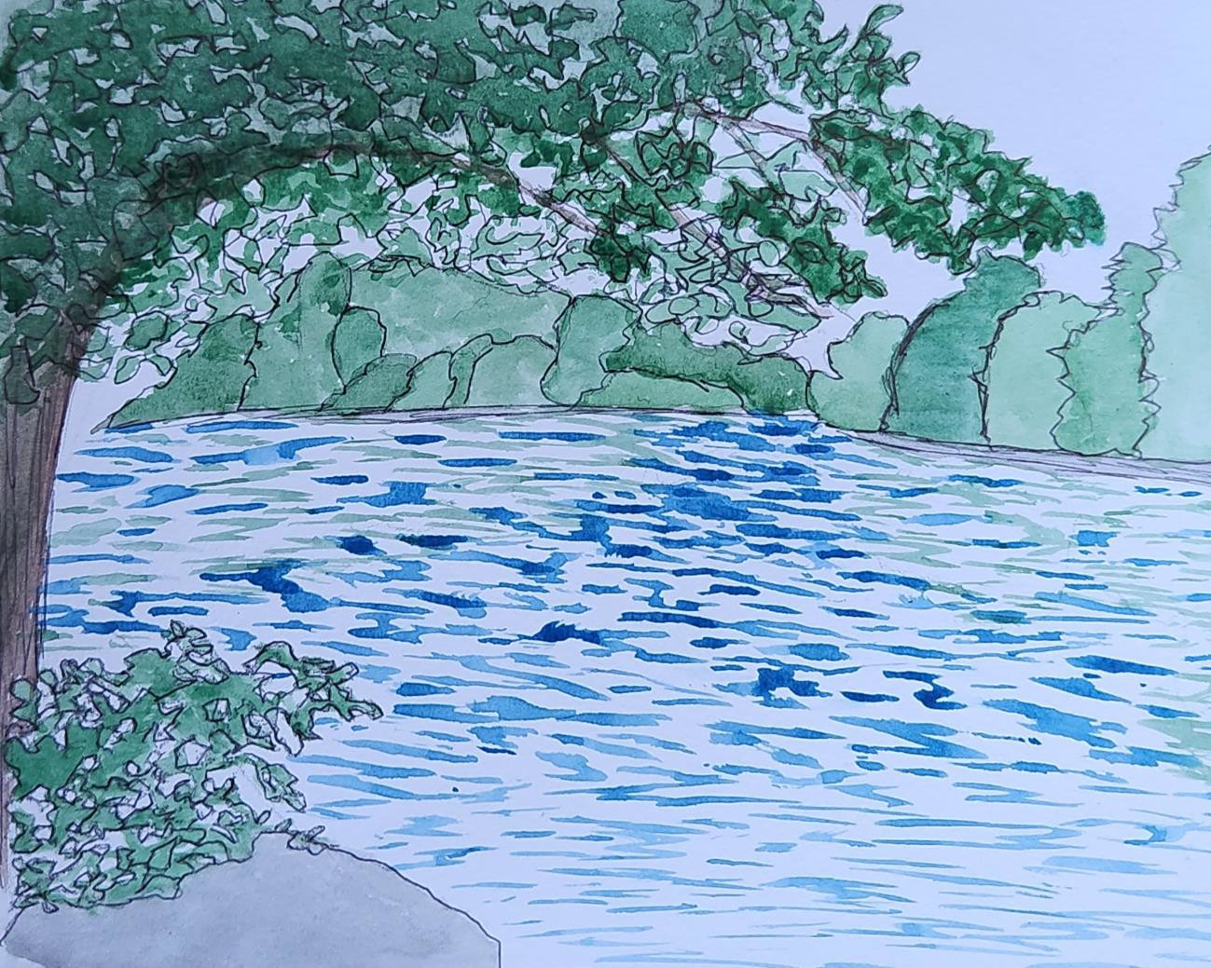
While reflecting on the meaning of Qu Yuan’s questions and attempting to create my own authentic answers for them, I was reminded of our earlier discussion of rivers and their significance to cultures around the world. For our river assignment, I painted the Duwamish River and as these two assignments feel so connected to me, I would like to share it here as well.

Fatima:
Title: Still Asking Heaven
Qu Yuan’s Question:
“Why were the stars scattered across the sky—who set them in motion?”
My Response:
Maybe they’re breadcrumbs
left by ancestors
guiding us through midnight struggles.

Maybe God knew we’d be out here
trying to find light when we feel lost.
So they gave us stars
and stories
to remind us:
we’ve always had a path
even when the map feels torn.

Original Question to Heaven:
Why do Black girls have to carry whole bloodlines on our backs
and still be told we’re "too much"
when we shine?

Reflection:
When I read about Qu Yuan being exiled and misunderstood, I thought: damn, that hits home. Black folks, especially women—know what it means to be cast out for being too passionate, too bold, too honest. Like Qu Yuan, we turn pain into poetry, displacement into rhythm, and legacy into light.
His "Questions to Heaven" made me think of all the times I’ve looked up angry,
confused, tired and wanted to scream, "Why?" The world still feels like a Warring State. We’re fighting systems, stereotypes, and generational curses. And still, like him, we write.
We question. We create.
This assignment reminded me that my voice is part of something ancient. Maybe not dragon boats, but the way we celebrate Juneteenth, or dance under summer suns that’s ancestral too. Our festivals might not look the same, but they carry the same heart: remembrance, resistance, rebirth.

Thomas

Questions to the Universe “Dialogues with Heaven”

1. I stared at these two questions for over three hours, attempting to capture my feelings with words. These specific questions flooded my brain with thoughts, questions, and images of creation. My mind was running wild with ideas of how to write my responses. After reading dozens of poems and philosophical quotes online and writing a similar amount of my own, I was finally able to express my thoughts.

"In the primal dawn of time, who passed down the tales?"
The essence of the cosmos entwined,
woven into the fabric of the universe,
creating the tapestry of our very existence.

"Brightness and darkness alternating—what force drove them?"
To understand the forces that separated light and dark, one must first recognize the interconnection that once bound them.

2. I have too many questions I would like to ask the universe. These are the three I settled on for now.
Why is there suffering of innocent people in the world?
Is there a relationship between faith and science?

How can humans align with the path of the universe?I created this art in our journal (markers, colored pencils, and icons pens) as an interpretation of my poem response to Qu Yuan’s question,
"In the primal dawn of time, who passed down the tales?"
The essence of the cosmos entwined,
Woven into the fabric of the universe,
Creating the tapestry of our very existence.

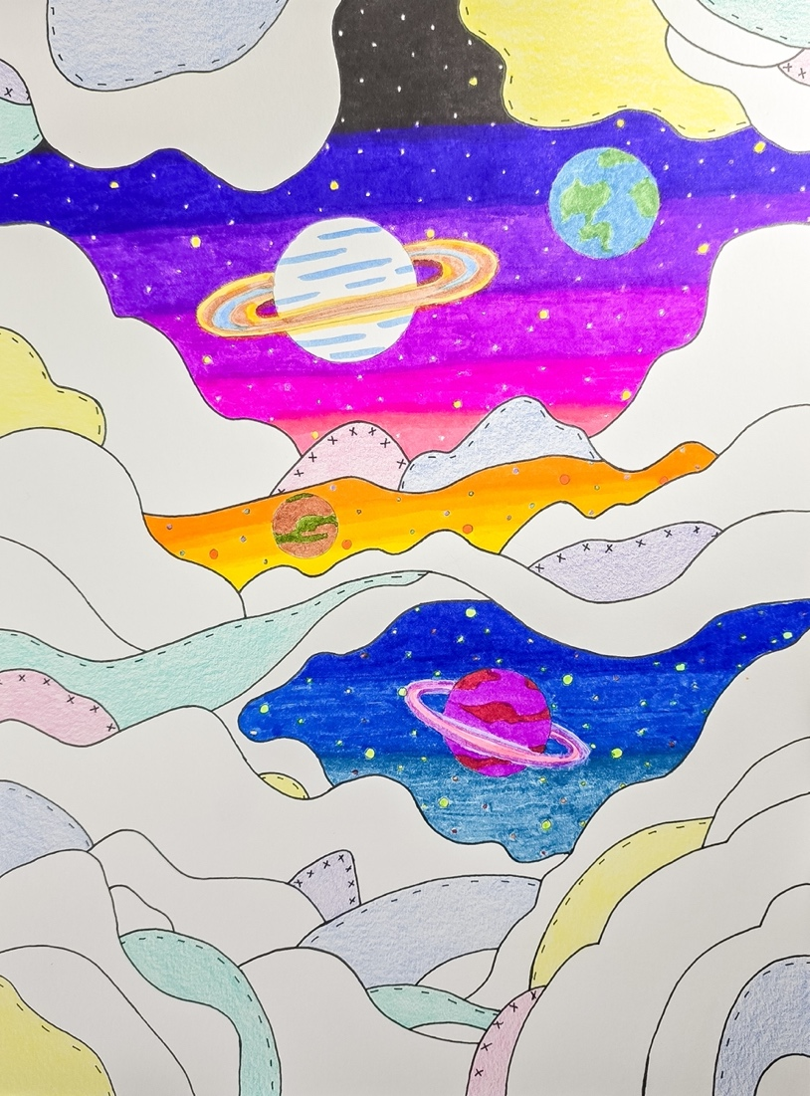

MarIah Jett
1.
O Sky, where satellites blink like cold stars,
Do you mourn the silence of forests
as we upload our prayers to the cloud?
2.
Heaven, where do the lost signals go—
the messages we text in heartbreak,
never read, never answered?
3.
You who once birthed suns from nothing,
Can you still see the soul
beneath algorithms and glowing glass?

D.J.
At the heart of Qu Yuan’s poem Questions to Heaven is a deep search for truth, justice, and understanding in a world that often feels too big and too broken. One of his lines that stood out
to me was: “Why are the heavens so far, and the earth so vast?” In my own words, I think it’s
because maybe the heart was never meant to stay in one place. Maybe we’re supposed to
stretch between joy and sorrow, between pain and purpose just to understand who we are.
Sometimes life feels overwhelming, and that distance between heaven and earth is the space
where we try to figure things out.

Inspired by Qu Yuan’s voice, I wrote a few questions of my own: Why do we carry pain that
doesn’t belong to us pain passed down through generations like old furniture? Can the heavens
still hear the prayers of people who’ve stopped believing in answers? And if silence could
speak, would it scream or would it sing? These are questions that sit heavy on my heart,
especially in times when the world feels like it’s still stuck in its own version of the Warring
States through injustice, racism, and disconnection.

Qu Yuan’s exile reminds me of the feeling of being unseen or pushed aside for being real. He
turned his pain into poetry, and that’s something I try to do in my own way too through reflection,
through creating, through telling the truth even when it’s uncomfortable. His life shows that you
can be misunderstood and still leave behind something meaningful. If he were alive today, I
think he’d be asking some of the same questions we are now. And maybe that’s the point that
even across centuries, we’re still searching for healing, still asking heaven for answers, still
trying to make sense of our place in the world.

Angel:
Question: "Brightness and darkness alternating—what force drove them?"
(What compelled light and shadow to first divide?)
Before there were words to name it,
There was only nothingness.
In the silence of the void,
A glimmer stirred,
Soft as breath,
Until it became a roar.
Light burst forth,
And in its wake,
Shadow followed.
Not as absence,
But as echo.
And so they parted.
Not in conflict,
But in becoming.

Question: In the primal dawn of time, who passed down the tales?"
(Who witnessed and narrated creation’s very
beginning?)

The tales of creation were not passed down by
voices, but by creation itself. The stars, the
stones, the trees, the rivers, they all remember.
Creation recorded itself in light, in rhythm, in
pattern. We are not the first storytellers, only
the first to speak aloud.

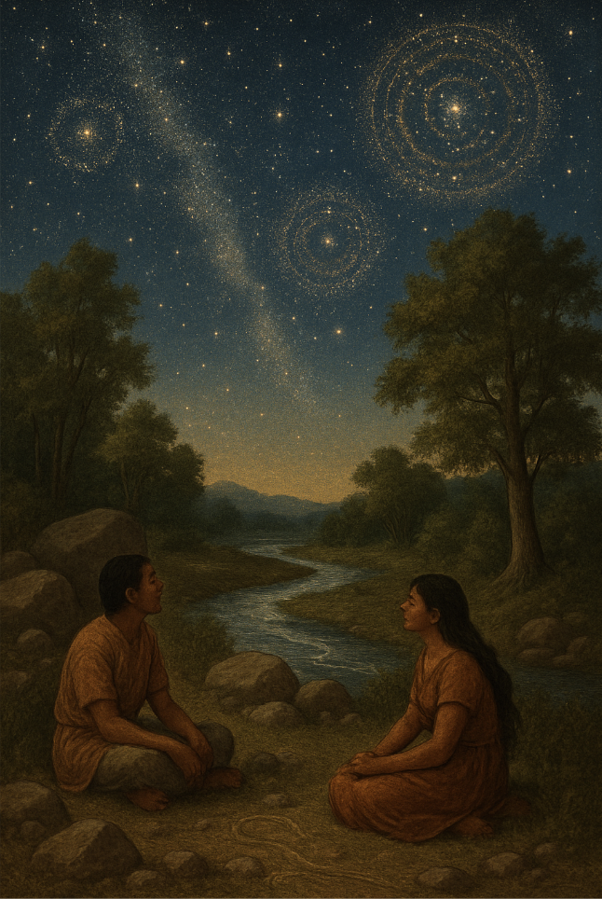

Railly:
- "Why did Nüwa mend the heavens, yet leave the world in chaos?"
  - Maybe it is perfection we chase, but wholeness and order exist without chaos; what's one without the other?
- "Why did the sun and moon rise and fall, yet never meet?"
  - Bound by nature to chase but never meet, some destinies are meant to never meet and yet create life.
- "Who set the stars in motion, and do they follow a path or wander freely?"
  - The stars move like a written book showing what has already been, yet who they follow a secret only they can share.
Jesse:
Selected Verses from Tian Wen ("Questions to Heaven")

"Who passed down the tale of the beginning of old? How can we know what shape the world had before the sky and earth were set apart?"
"Why does the sun and moon not fall? How do the stars stay ﬁxed in their places?"

"Who controls the rise and fall of dynasties? Who decides which ruler will prosper and which will fall?"
"The tale of beginnings is written in stone, in the whispers of rivers, the cracks in old bone. Before earth and sky, there was only the hum— the breath of the void, the beat of the drum."

"The sun and moon dance on threads unseen, woven by time in a cosmic machine.
The stars are not ﬁxed but swim like bright ﬁsh, circling the heavens in an inﬁnite wish."

"Dynasties rise like tides on the shore, shaped by the many, not kings anymore. The wheel of fortune turns without hand— fate is a seed sown in blood, sweat, and sand."

Modern Questions:

"Who programmed the ﬁrst line of code in the void? When machines outthink us, will we be destroyed?"
"Why do we burn the only home we possess? Who will answer when Earth sighs in distress?"

"If love is just chemistry, why does it ache? Who decides which hearts get to break?"

Destinee:

冥昭瞢暗，谁能极之？
Pinyin: Míng zhāo méng àn, shuí néng jí zhī?

Translation:

"In the blur of dark and light, who could discern its limits?" (Who grasped the chaos before day and night parted?)

Endless:

Endless limits of dark and light Beautiful swirls of blues and whites The perfect yin yang in the skies

We sit on that mountain

Looking up toward the swirling stars and clouds We fade, we fade to nothing
Plants are growing around us We start sinking

The endless nights and days are getting further away Trying to reach for the swirls of the stars and clouds We sink further down

The world seems to be out of reach We are out of reach

